**Chef- Reporting**

Before chef reporting you should see error like below

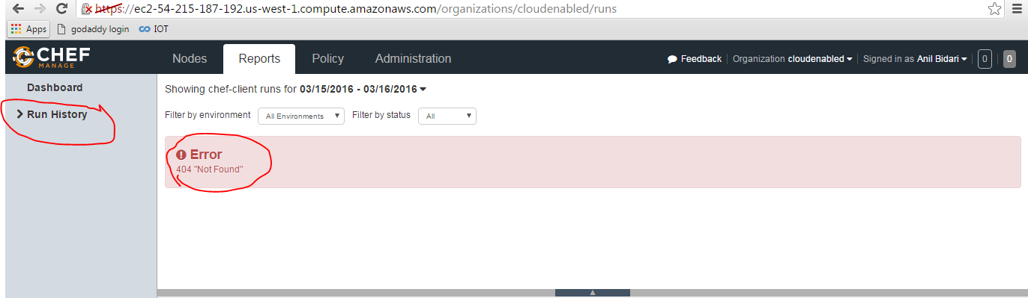

**Option I**

**Step 1 : Install Chef- reporting**

# chef-server-ctl install opscode-reporting

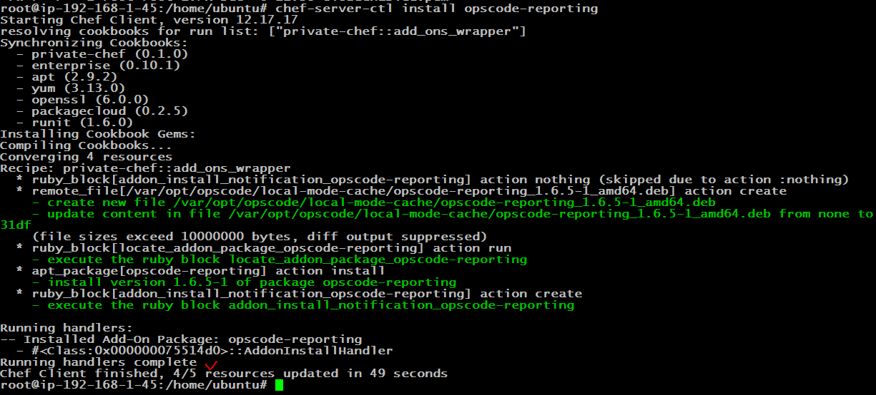

**Step 2 : Reconfigure chef-server**

# chef-server-ctl reconfigure

# opscode-reporting-ctl reconfigure

**Press Enter**

**Press q**

**Type “yes” and hit enter**

**Option II ( to install)**

wget https://packages.chef.io/stable/ubuntu/14.04/opscode-reporting_1.6.4-1_amd64.deb

**Install opscode reporting**

dpkg -i opscode-reporting_1.6.4-1_amd64.deb

**Reconfigure chef-server**

# chef-server-ctl reconfigure

# opscode-reporting-ctl reconfigure

**Refresh web browser and go to Reports > Run history**

